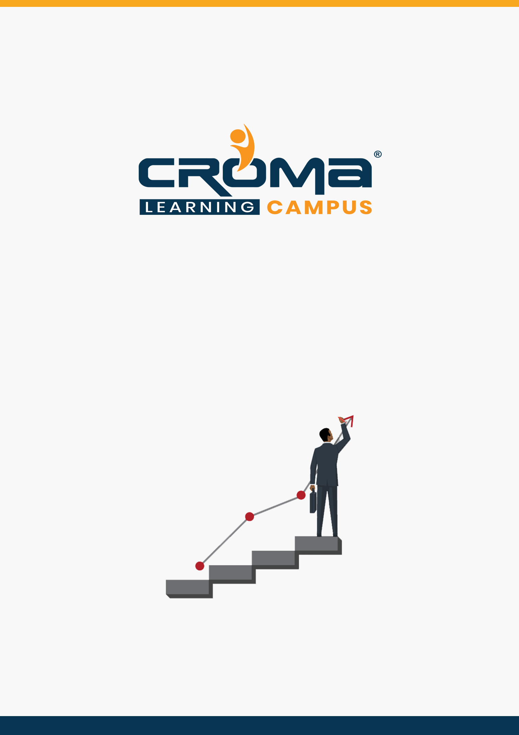

**SAP ABAP Training Curriculum**

**STRUCTURE**

**www.cromacampus.com | helpdesk@cromacampus.com | +91-120-4155255**

**SAP ABAP Training Curriculum**

*“Our SAP ABAP makes sure that you are way ahead of your colleagues. So, hurry up and enroll today to work smartly.”*

**Course Objectives:**

* Learn the fundamental ABAP programming skills and start creating your own ABAP program.
* Learn ABAP basics, terms, and terminologies at the initial level then you can move to the advanced learning.
* Learn language elements and cover more topics like building report interfaces, modularizing your programs, and Function modules, etc.
* Get a depth insight into SAP programming language, become an ABAP expert and start applying for jobs after completing the course with us.
* Prepare yourself for the global certification exam and gain credentials that are valid worldwide.

**Course Description:**

SAP ABAP is a popular enterprise programming language developed by the SAP and utilized by leading companies worldwide to run their business systems effectively. In our SAP ABAP Training course, you will learn the fundamental ABAP programming skills and start creating your own ABAP program.

Our training starts from basics to advanced so anyone can join it instead of their proficiency levels. Once you are sure ABAP basics, terms, and terminologies, you can learn language elements and cover more topics like building report interfaces, modularizing your programs, and Function modules, etc.

Our ABAP training program not only gives you a depth insight into SAP programming language but makes you an ABAP expert so that you can start applying for jobs after completing the course with us. Our mentors make it so easy to learn that you will be writing and testing out the code in no time.

The SAP ABAP course is generally intended for:

* Beginners through to season SAP Consultants,
* SAP Functional Consultants looking to learn ABAP skills,
* SAP Project Team members,
* College Students wanting to get ahead with their studies,
* SAP BASIS Consultants wanting to expand their knowledge, SAP BW Consultants etc.

Most importantly, the course focuses on learning through a practical approach where everything is explained through examples and a step-by-step guide to ABAP programming. Even if you are a beginner, the course is your guide to rapid and real-world enterprise software development.

**Course Content:**

1. **Introduction to ERP**

* What is ERP?
* Why we need ERP?
* Advantages of ERP
* Major ERP Packages

1. **Introduction to SAP & R/3 Architecture**

* What is SAP?
* History & Features of SAP
* SAP R/2 Architecture (Limitations of R/2 Architecture)
* SAP R/3 Architecture (Types of work processes)
* SAP R/3 Application Modules
* SAP Landscape

1. **Introduction to ABAP/4**

* What is ABAP?
* Logon to SAP Environment
* Transaction Codes
* Multitasking Commands
* Comments
* Errors

1. **ABAP/4 Editor (SE38)**

* Steps for Creating a Program
* Elements in R/3 Screen
* Output Statements
* Operators in ABAP
* Data, Parameter & Constant Statements
* Data Types & Classification
* Data Objects & Classification
* Text Elements
* String Operations
* Control Statements
* Field Strings

1. **ABAP Dictionary**

* ABAP Dictionary Introduction
* Data Dictionary Functions
* Data Dictionary Objects
* Data Base Tables
* Structures
* Views
* Data Elements
* Type Groups
* Domains
* Search helps
* Lock objects
* Primary Key and Foreign Key
* Table Maintenance Generator

1. **Packages**

* Creating a package
* Difference between local objects & packages
* Transferring local objects to packages

1. **Variants**

* Variants Introduction
* Creating variants in ABAP Editor & Data Dictionary

1. **Message Classes**

* Message Class Introduction
* Message types
* Calling message class in Report & Dialog programs

1. **Reports**

* Reports Introduction
* Selection screen Introduction
* Parameter Statement
* Select-options Statement
* Selection-screen Statement
* Screen table and its fields
* Dynamic screen modification by using Modify Id key
* Selection Screen Begin of block End of block
* Include Sub-screen in Selection screen, Selection Screen Pushbutton
* Selection screen buttons on application toolbar
* Selection Screen begin of line End of line, Comments in Selection Screen
* Selection Screen Radio button, Check Box, List Box
* Selection Screen Select options no extension no intervals, Initial Values to Select Options
* Working with Events in Classical Report: Initialization, At Selection-screen At Selection-Screen on Field, At Selection-Screen on block, at selection-screen on Radio button, At Selection-screen on Value Request, at selection-screen on help-request, at selection-screen Output, start-of-selection, end-of-selection, top-of-page, end-of-page
* Working with Events in interactive Report: At line-selection, At user-command, At PFN, Top-of-page During Line selection
* Interactive Report Concepts: Hide keyword, Various system Defined Fields used, Hotspot, Get Cursor field.

1. **Open SQL Statements**

* Select
* Insert
* Modify
* Update
* Delete

1. **Internal Tables**

* Internal Tables Introduction, Internal table with header line / Without header line
* Declaring Internal Table, Types of internal table
* Populating Internal Table, Operations of Internal table
* Processing Internal Table
* Initializing Internal Tables
* Inner Joins and For All Entries
* Control Break Statements

1. **Debugging Techniques**

* Debugging Techniques Introduction
* Break-points (Static & Dynamic)
* Watch points
* Dynamically changing internal tables contents in Debugging Editor
* Options to step through the program in Debugging Editor

1. **Modularization Techniques**

* Modularization Techniques Introduction
* Includes
* Subroutines
* Passing Parameters to Subroutines
* Passing Tables to Subroutines
* Function Groups & Function Modules

1. **Dialog / Module Pool Programming/ Transactions**

* MPP Introduction
* Relationship between Screen, Flow Logic and Program
* Flow Logic Events
* Reading input Fields from Data Dictionary & Updating into Screen input Fields
* Working with List box Creating
* At exit Command
* Process Before Output (PBO)
* Process on Value Request (POV)
* Process on Help Request (POH)
* Dynamic Screens, On input, On Chain-Input, on Request, On Chain-Request
* Leave Screen
* Leave to Screen
* Call Screen
* Set Screen
* Processing of List from Transaction and Vice Versa
* Field / Group of field validation using Chain End chain Concept
* Elements in Screen Layout
* Table Controls, Status icon
* Step Loops
* Tab strip Controls
* Sub-screens
* Screen Elements Grouping & Modification Using Loop at screen concept
* Custom control, creating screen ALV using Custom Control & Docking Control

1. **Batch Data Communication**

* BDC Introduction
* Recording
* BDC Methods: Executing with Include Program & Executing custom Program without include program
* Call Transaction Method: Uploading Excel file with File Path attached to input field
* Call Transaction Method: Error Handling / Storing the errors in Data Dictionary Table or in excel format
* Session Method
* Scheduling Session Method in background
* Handling Table Controls in BDC
* Legacy System Migration Workbench
* Legacy System Migration Workbench: Different Methods
* Flat file creation
* Uploading data
* File Handling
* Application Server
* Presentation Server

1. **OOPS Concept (ABAP Objects)**

* Object Oriented ABAP Overview
* Defining a Class
* Implementing a Class
* Working with methods & Attributes
* Method Parameters: Importing, Changing, Exporting, Returning
* Events, Event Handlers, Registering Events
* Creating Objects & Working with Objects
* Singleton Class
* Inheritance
* Interface, Nesting Interfaces
* Abstract Class & Methods
* Final class & Final Methods
* Private Class
* Statics: Static Attributes Class-Data, Static Methods Class-Methods
* Constructor
* Static Constructor
* Creating ABAP Object ALV Programs
* Factory Method
* Functional Methods
* Narrow Cast & Widening Cast
* Polymorphism
* Self-Referencing
* Create Global Class using the class Builder
* Creating Global class for Inheritance, Interface, Polymorphism, Final Methods, Abstract Methods

1. **ALV Reports**

* ALV Reports Introduction
* ALV through Function Modules
* ALV through ABAP Objects
* ALV List & Grid
* ALV for Line Color, Column color
* Edit ALV, Update the values in ALV
* Block ALV
* Hierarchical ALV
* List Tree ALV
* Screen Tree ALV
* Events in ALV
* Interactive ALV in List & Gird
* Interactive ALV in ABAP Objects
* Screen ALV drag & drop
* Adding buttons in ALV
* ALV Variants
* Checkbox In ALV
* Popup to Select in ALV
* Sorting & Page break in ALV
* Adding pictures to ALV
* Custom menu in ALV
* Saving layouts
* Event after line output
* Menu painter Interactive

1. **SAP Scripts**

* SAP Scripts Introduction
* Components of SAP Scripts
* Layout Set
* Standard Text
* Out Put Program
* Modifying Standard SAP Script Layouts
* Including Logos
* SAP Script Utilities – Upload / Download

1. **Smart Forms**

* Smart Forms Introduction
* Graphics Management
* Style Maintenance
* Paragraph Formats
* Character Formats
* Writing print program and designing layouts

1. **Runtime Analysis & SQL Tracing**

* ABAP Runtime Analysis: SE30 / SAT
* SQL Trace: ST05
* System Trace: ST01
* ABAP Dump Analysis: ST22
* Performance Trace: ST12
* ABAP Extended Program Check: SLIN

1. **Cross Applications**

* Introduction to Distributed Environment
* Introduction to Cross Applications

1. **RFC**

* Introduction to RFC
* Creating RFC Destination between 2 Systems
* Creating Remote Enabled Function Modules
* Creating program using Remote Enabled Function Modules
* Types Of RFC
* Create Programs for Different RFC Types

1. **EDI**

* EDI Basics
* Difference between ALE & EDI
* Overview of Outbound & Inbound Process
* Configuration Steps
* Port Creation
* Partner Profile Creation

1. **BAPIs**

* BAPI Overview
* Creation of BAPI

1. **Workflow**

* What is workflow?
* Overview of workflow

1. **User Exits**

* User Exits Overview
* Types of User Exits
* Field Exit
* Screen Exit
* Function Exit
* Menu Exit

1. **BADIs**

* BADIs Overview
* Defining a BADI
* Implementing a BADI

1. **Miscellaneous Topics**

* Correction & Transport request (CTS)
* Transport Organizer
* Work Bench Request
* Task Creation
* Release Objects
* SAP Memory & ABAP Memory
* Logical Database
* SD Flow
* MM Flow

1. **Placement Guide**

* Tips to Clear an Interview
* Common Interview questions and answers
* SAP ABAP Interview Questions and Answers
* Resume Building Guide
* Attempt for SAP ABAP Global Certification Exam
* Earn Credentials and Start applying for Jobs